**8.12 Choice Option (Combo) In Java :-**

# Java AWT Choice

The object of Choice class is used to show [popup menu](https://www.javatpoint.com/java-awt-popupmenu) of choices. Choice selected by user is shown on the top of a menu. It inherits Component class.

## AWT Choice Class Declaration

**public** **class** Choice **extends** Component **implements** ItemSelectabl, Accessible

## Java AWT Choice Example

**import** java.awt.*;

**public** **class** ChoiceExample

{

        ChoiceExample(){

        Frame f= **new** Frame();

        Choice c=**new** Choice();

        c.setBounds(100,100, 75,75);

        c.add("Item 1");

        c.add("Item 2");

        c.add("Item 3");

        c.add("Item 4");

        c.add("Item 5");

        f.add(c);

        f.setSize(400,400);

        f.setLayout(**null**);

        f.setVisible(**true**);

     }

**public** **static** **void** main(String args[])

{

**new** ChoiceExample();

}

}

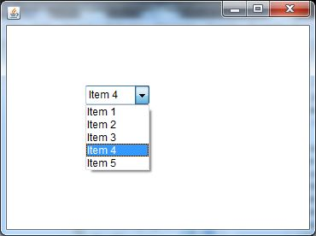

The Choice class presents a pop-up menu of choices. The current choice is displayed as the title of the menu.

The following code example produces a pop-up menu:

Choice ColorChooser = new Choice();

ColorChooser.add("Green");

ColorChooser.add("Red");

ColorChooser.add("Blue");

In the picture, "Green" is the current choice. Pushing the mouse button down on the object causes a menu to appear with the current choice highlighted.

Some native platforms do not support arbitrary resizing of Choice components and the behavior of setSize()/getSize() is bound by such limitations. Native GUI Choice components' size are often bound by such attributes as font size and length of items contained within the Choice.

In this section, you will learn how to create Drop-Down List by using Java AWT package.

you will see in the output of the program that is given ahead for the illustration of the topic. This tells you about the procedure of constructing a drop down list in java by using java awt.

There is a program with complete java code that can be copied and paste in your java application for creating a combo box with some items, has been explained here:

Following program uses the **Choice** class for creating a Drop-Down List. This program is also using ***add()*** method of the **Choice** class for add item to the list like "ROSE", "INDIA" and "WELCOME".

**Choice():-** This is the default constructor of **Choice** class.This creates simply a drop-down list.

|  |
| --- |
| **import**java.awt.*; **import**java.awt.event.*; **public class**ChoiceOptionExample{   **public static void**main(String[] args) {   Frame frame=**new**Frame("Choice");   Label label=**new**Label("What is your Choice:");   Choice choice=**new**Choice();   frame.add(label);   frame.add(choice);   choice.add("ROSE");   choice.add("INDIA");   choice.add("WELCOME");   frame.setLayout(**new**FlowLayout());   frame.setSize(250,150);   frame.setVisible(**true**);   frame.addWindowListener(**new**WindowAdapter(){    **public void**windowClosing(WindowEvent e){   System.exit(0);    }   });  }  } |

